**UNIT 4 : LEARNING A FOREIGN LANGUAGE**

**PERIOD 5: READ ( HỌC SINH TỰ HỌC)**

**Task 1: Identified the types of these samples**

1. 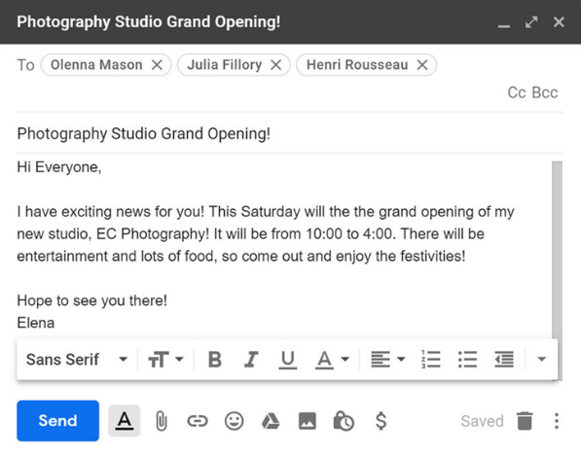 **2.**

**3. 4.**

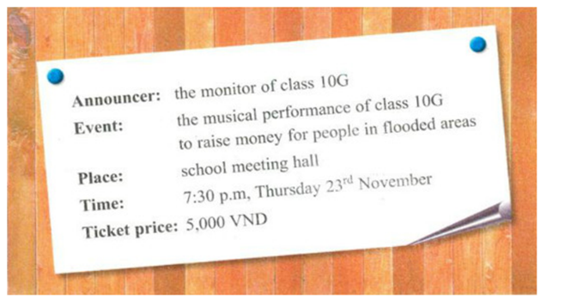

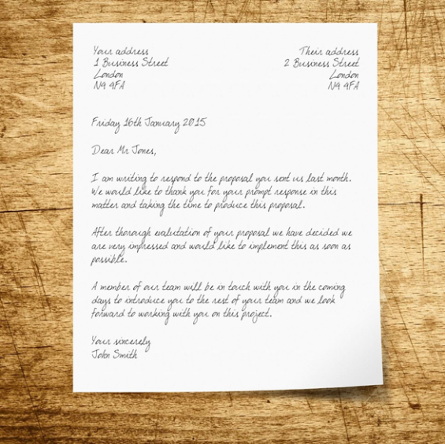**5.**

**Answer: 1. ____________ 2. ___________**

**3. ___________ 4. ____________**

**5. ____________**

**VOCABULARY:**

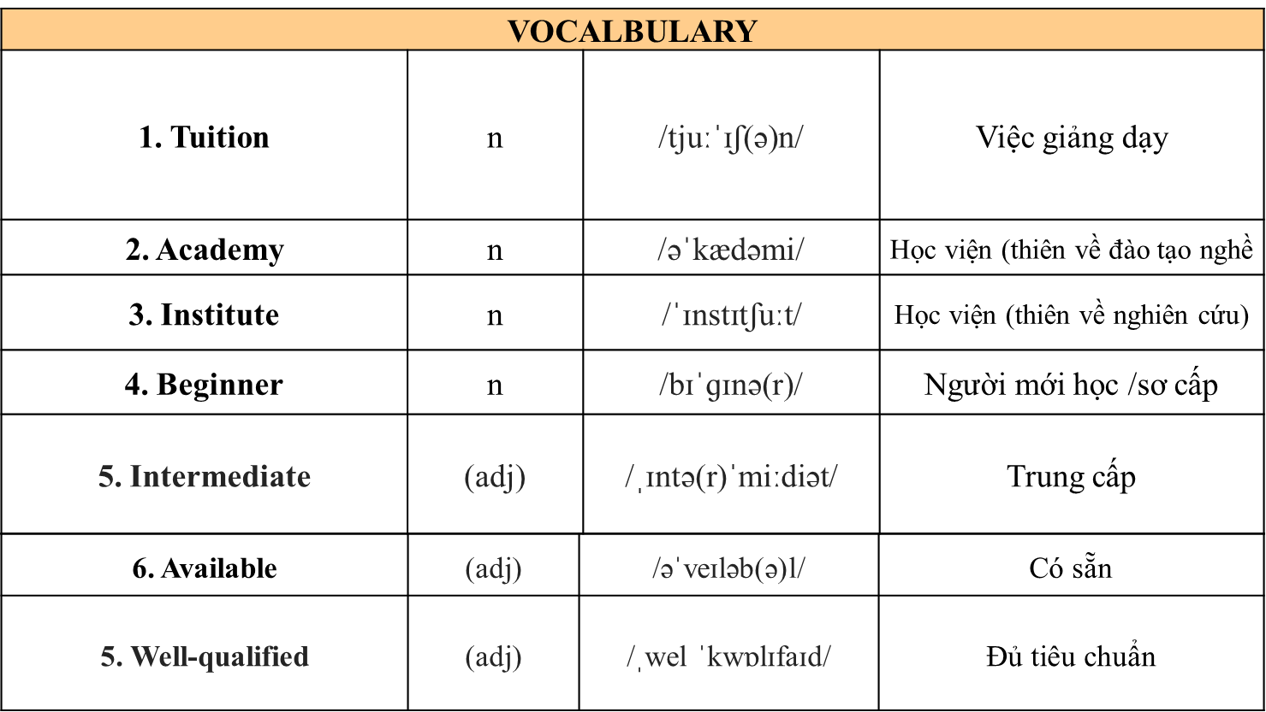

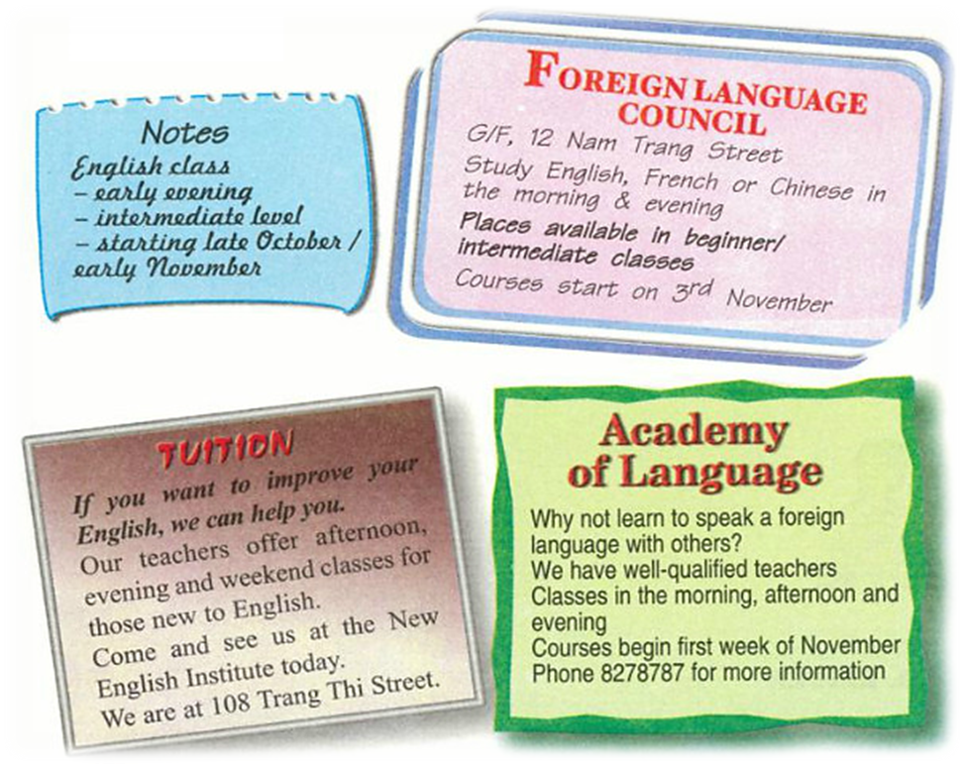**Task 2 : Read**

***a. Note down information about the English classes from the advertisenments.***

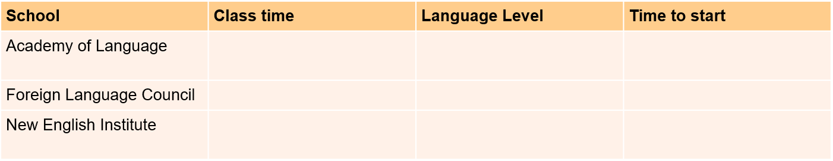

***b. Read the notes Mr.Lam made. Then look at the advertisements and choose a suitable language school for him. Give reasons for your choice***

**Task 3 : Watch a short video then decide if the information is True or False**

